SPH4U Investigating Relationships Introductory Experiment Group Members:
Introduction: In this investigation, your focus will be to determine the quantitative relationship between the independent and dependent variables. You will graph the initial relationship between the variables, identify the general type of relationship and then perform graphical analysis steps to determine the exact quantitative relationship.
In this lab, all graphs will be hand drawn! A formal lab report will be typed and submitted in class and through Turnitin (on D2L). Refer to the Scientific Investigation Report file on how to write up a formal report and a sample report.
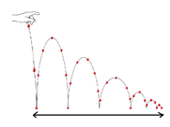
Experiment 1: What is the relationship between release height (Δh) and time for six bounces (Δt) when a “superball” 0.3 is released from various heights ranging from 0.10 m to 1.00 m.
Record the time for 6 bounces. Start the stopwatch and count “Zero” when you hear the first bounce. Stop the stopwatch when you count the 6th bounce.
Make sure to repeat each trial at least THREE times!
Materials: superball, metre stick, stopwatch

Experiment 2: What is the relationship between vertical launch height (Δh) and horizontal range (Δd) when a projectile (ball bearing) is launched horizontally at a constant initial speed.
Use a range of release heights of 10.0 cm up to 60.0 cm. Increase the release height by 5.0 cm each time. Make sure that the angle of the projectile ramp is kept constant and that the base of the ramp is horizontal for each launch!
Make sure to repeat each trial at least TWO times.
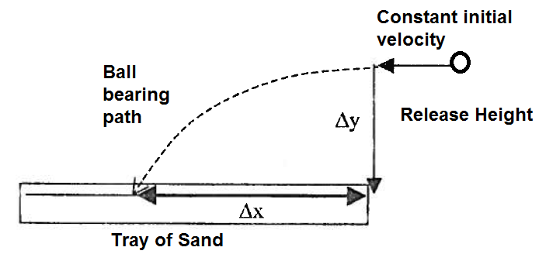
Materials: projectile ramp, retort stand, C-clamp, test tube clamp, ball bearing, metre stick, ruler, box lid, sand

Experiment 3: What is the relationship between terminal velocity (v) and mass (m) for an object (stack of coffee filters) dropped from rest from a fixed height?
Terminal velocity is the final velocity reached by an object accelerating through a fluid such as air or water, when the upward resistive force due to air resistance or water drag grows to balance the downward force of gravity on the object. When the forces on the falling object become balanced, it stops accelerating and begins falling at a constant velocity referred to as the terminal velocity.
Terminal velocity depends upon object shape as well as mass. In this case, we will use a stack of coffee filters which maintain their shape even if individual filters are removed from the stack. We will use the motion sensors to collect the d-t graph for the falling filters. Once you observe the graph become a straight diagonal line, you will know that terminal velocity has been reached. Find the terminal velocity from the slope of the straight portion of the d-t graph using the Linear Regression tool to find the slope. Repeat each trial one more time so you can get an average terminal velocity.

Start with a stack of 10 filters, measure the mass using the mass balance and then find the terminal velocity by dropping the stack from a height of approximately 2.0 m from above the motion sensor. Remove ONE filter at a time so that you have 10 different mass values.
Materials: Stack of 10 coffee filters, mass balance, motion sensor, metre stick
Motion Sensor
Note on errors: All group members should be in agreement regarding the uncertainty or error in each measured parameter.
Typically, for length measurements, error can be determined by repeating the measurements several times and examining the variation in the measured values.
For example, three measurements of the same length yield: 12.0 cm, 11.8 cm, 12.4 cm. The average value is 12.07 cm with a range of -0.27 cm to +0.33 cm. A good experimental value would thus be: 12.1 cm ± 0.3 cm. Note that the precision of the recorded value should match the precision of the uncertainty.
For time measurements with a stop watch, our reaction time typically gives an uncertainty of ± 0.1 s to ± 0.2s. However, to avoid unnecessary round-off errors, for raw time measurements we will record all digits on the stopwatch (to the nearest ± 0.01 s) and will round off the average value to one decimal place.
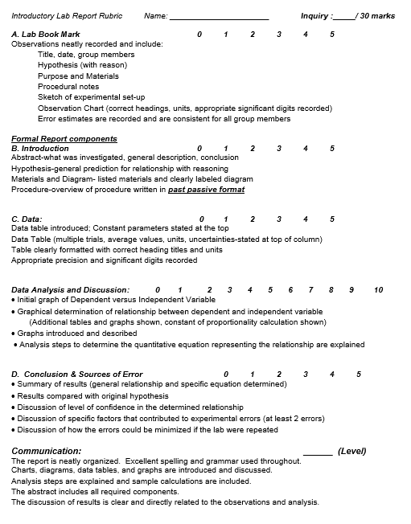
Pre-Lab Preparation: In your lab book, prepare the following sections: Purpose, Materials, Hypothesis, Observation Chart. For the hypothesis, prepare a brief prediction about how the independent and dependent variables will be related. In this case, predict if the relationship is increasing or decreasing. Give a reason for your prediction.

